<https://github.com/ssardarabdullah>

***ABBOTTABAD UNIVERSITY OF SCIENCE & TECHNOLOGY ABBOTTABAD***



# Lab Task No # 02

**NAME : Abdullah Niaz**

**SUBMITTED TO:** SIR JAMAL ABDUL AHAD

**COURSE**: OBJECT ORIENTED PROGRAM BS/SE

**SECTION :** C

**ROLL NO :** F24-1312

*i-:*

*INPUT*



***Output:***

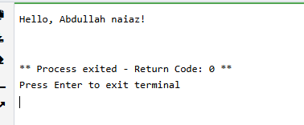

***ii-***:

INPUT

*Output:*

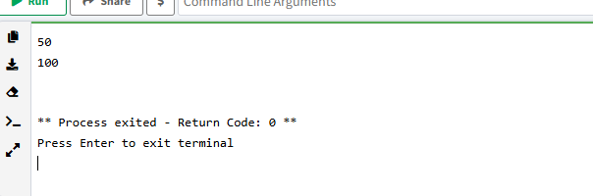

*iii-:*

*INPUT*

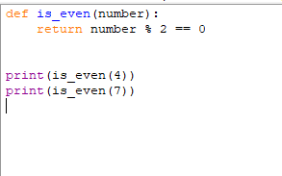

*OUTPUT:*

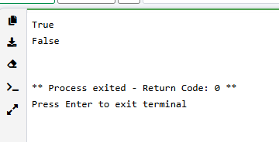

*iv-:*

# INPUT

*OUTPUT:*

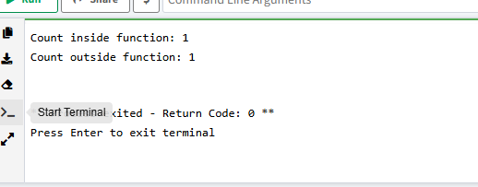

*v-:*

*INPUT*

*Input :*

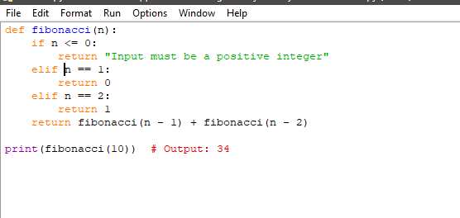

*OUTPUT:*

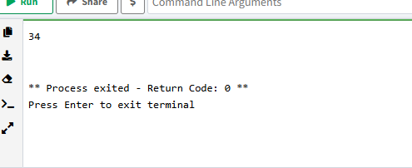

*vi-:*

INPUT

***OUTPUT:***

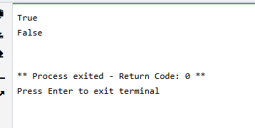

vii-:

INPUT

# INPUT:

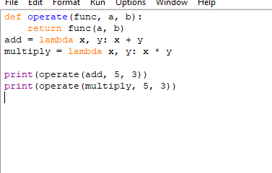

***OUTPUT***

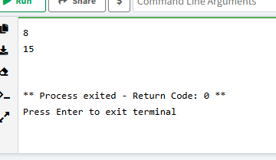

***viii:***

INPUT

their product

# INPUT:

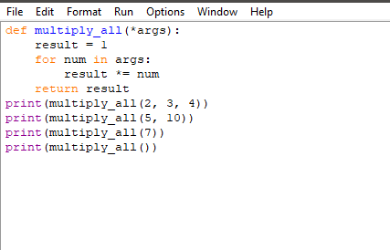

***OUTPUT:***

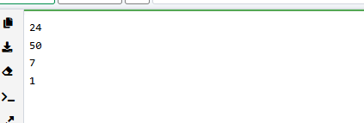

ix-:

# INPUT:

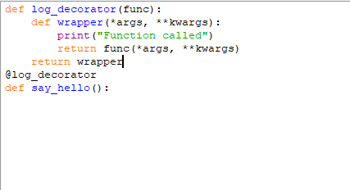

***OUTPUT:***

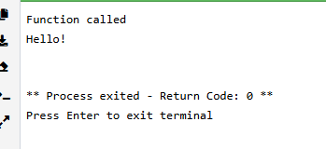

<https://github.com/ssardarabdullah>